1.

SELECT \*

FROM Employees;

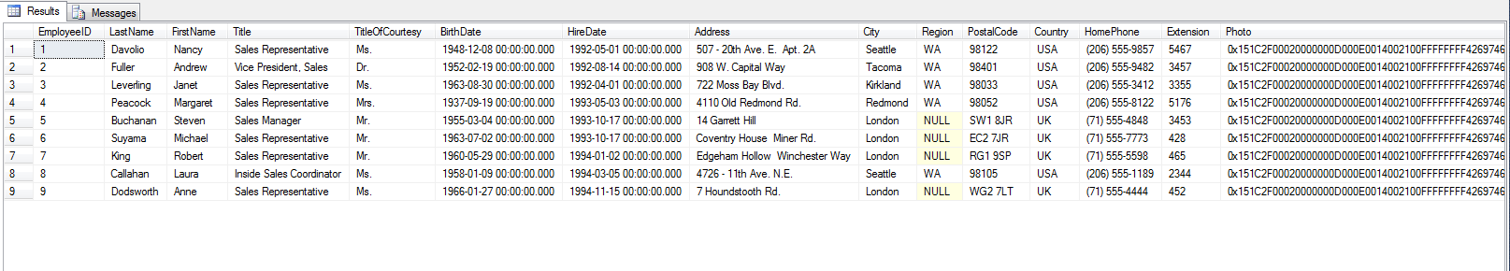

2.

SELECT \*

FROM Employees

WHERE title='Sales Representative';

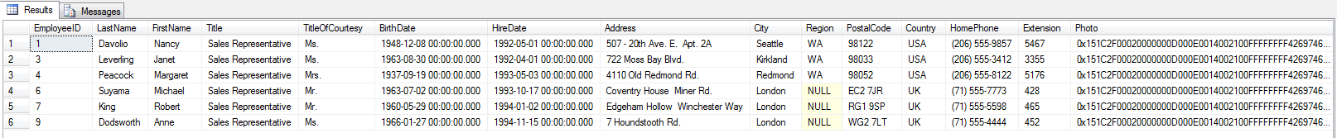

3.

INSERT INTO employees(LastName,FirstName,Title,TitleOfCourtesy,BirthDate,HireDate,Address,City,Region,PostalCode,Country,Extension,Notes,ReportsTo)VALUES('Smith','Janet','Sales Manager','Mrs.','12/30/1974','08/05/2000','123 My Street','Canton','OH','44720','USA',4632,'MBA from Ashland University',2);

SELECT \*

FROM employees

WHERE LastName='Smith';



4.

UPDATE employees

SET title='Sales Representative'

WHERE LastName='Smith' and FirstName='Janet';

SELECT \*

FROM employees

WHERE LastName='Smith';

